Game Design Document (GDD)

*2D Materials Quiz*

CONTENTS:

Purpose of this Document

Game Description

State Diagram

Screen Mockups

1. Purpose of this Document

* GDD is a standard document used in industry game design;
* A GDD should outline development goals and milestones in production;
* GDD should be available to all members of dev team to update with new information and changes to plans;
* GDD might seem pointless for very small projects (e.g. this one) but is best practice!
* Please mark any non-urgent informational notes with your initials ☺
* PLEASE MARK URGENT CHANGES/ISSUES IN RED TEXT WITH YOUR INITIALS.

1. Game Description

This game is a simple multiple-choice quiz on 2D materials physics for use as an outreach tool within the Physics Department at Heriot-Watt University.

A question will be picked at random from a pool of available questions, with two or more possible answers presented for the user to pick from. The user should click on an answer to proceed to the next question. Future implementation could be mobile/tablet based using touchscreen controls.

CM: This game will be implemented as a very simple finite-state machine[1] where, in this case, at each stage a given user interaction has a definitive outcome of one of two states (correct or incorrect) and a score updated accordingly.

1. State Diagram

Below are preliminary details the flow of user input from one question to the next via a correct/incorrect information screen. This could be implemented by either loading a separate scene or by changing the existing scene to display more information, e.g. if incorrect answer is selected, colour the answers according to correctness and display information about how the 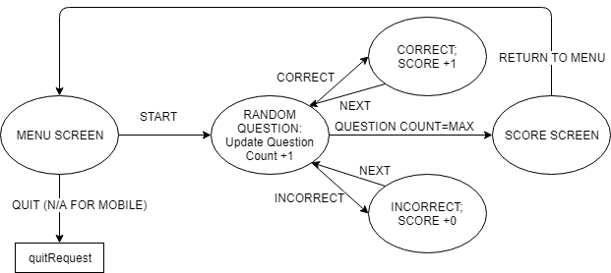correct answer is achieved.

Figure 1: State Diagram for Quiz. All arrows represent user interaction via a button click.

CM: arrow labelled QUESTION COUNT=MAX above could be changed from an END QUIZ button to being automated before proceeding to score screen.

1. Screen Mockups

On the way!

1. https://en.wikipedia.org/wiki/Finite-state_machine